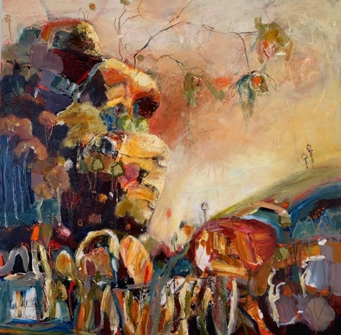
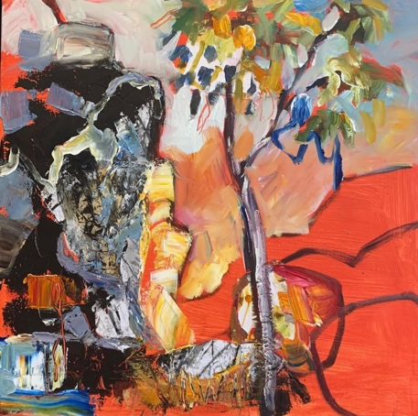
Responding to the Landscape- Ann Rayment

1 day workshop
Old Schoolhouse, 423 Croobyar are, Milton , NSW
Thursday 29th September
9:30-4pm
$130
A day in the garden of the historical Milton homestead, Old Schoolhouse, will be one where you can relax and have fun with other like-minded people.

This workshop is for those who want to loosen up their brushstrokes, use colour without overthinking and create an individual response to the landscape.

This is a relaxing workshop where we will learn many different techniques and use various mediums to produce a work with depth and freedom.

We will venture out into the landscape to respond with loose marks and sketches which we will use as collage in our work.

A material list is given on enquiry .
Some materials supplied.
Morning and afternoon tea supplied.
BYO lunch

Payment Details. : Ann Rayment
BSB 062564
ACCOUNT 10230051
Reference your full name

Questions - please ring me on 0409215107

